Modifications to 4008 117 08012

- Remove 2 square pad on top layer, refer to drawing below
- Remove track between round pad and square pad on solder side, refer to drawing below.
Note: this drawing is seen from top side.
- Change part number printed on top layer to 4008 117 08013
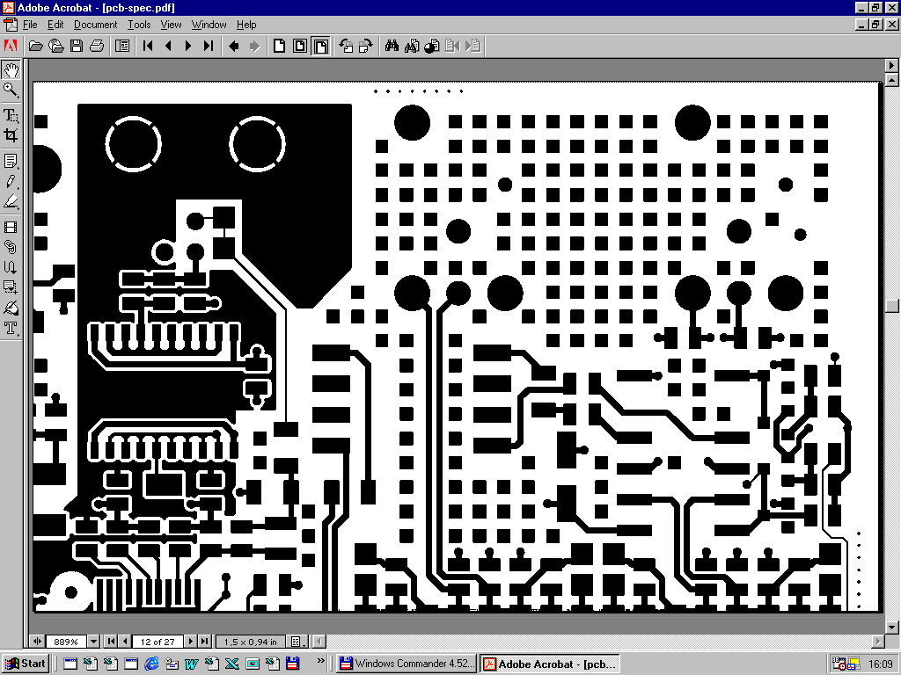
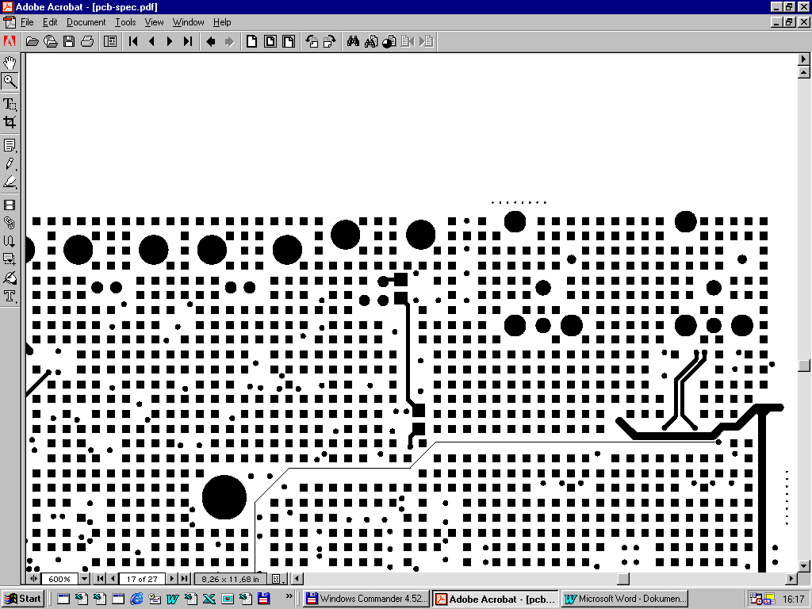
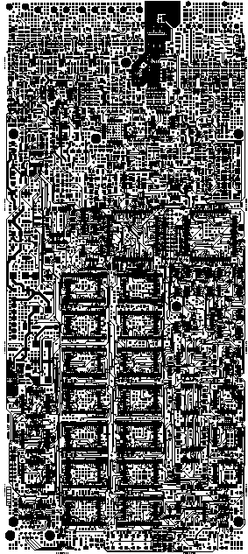
Remove 2 square Pads
Keep track !!!
Remove track between round pad and square pad
Part number
Area of modification:
Top and solder layer

